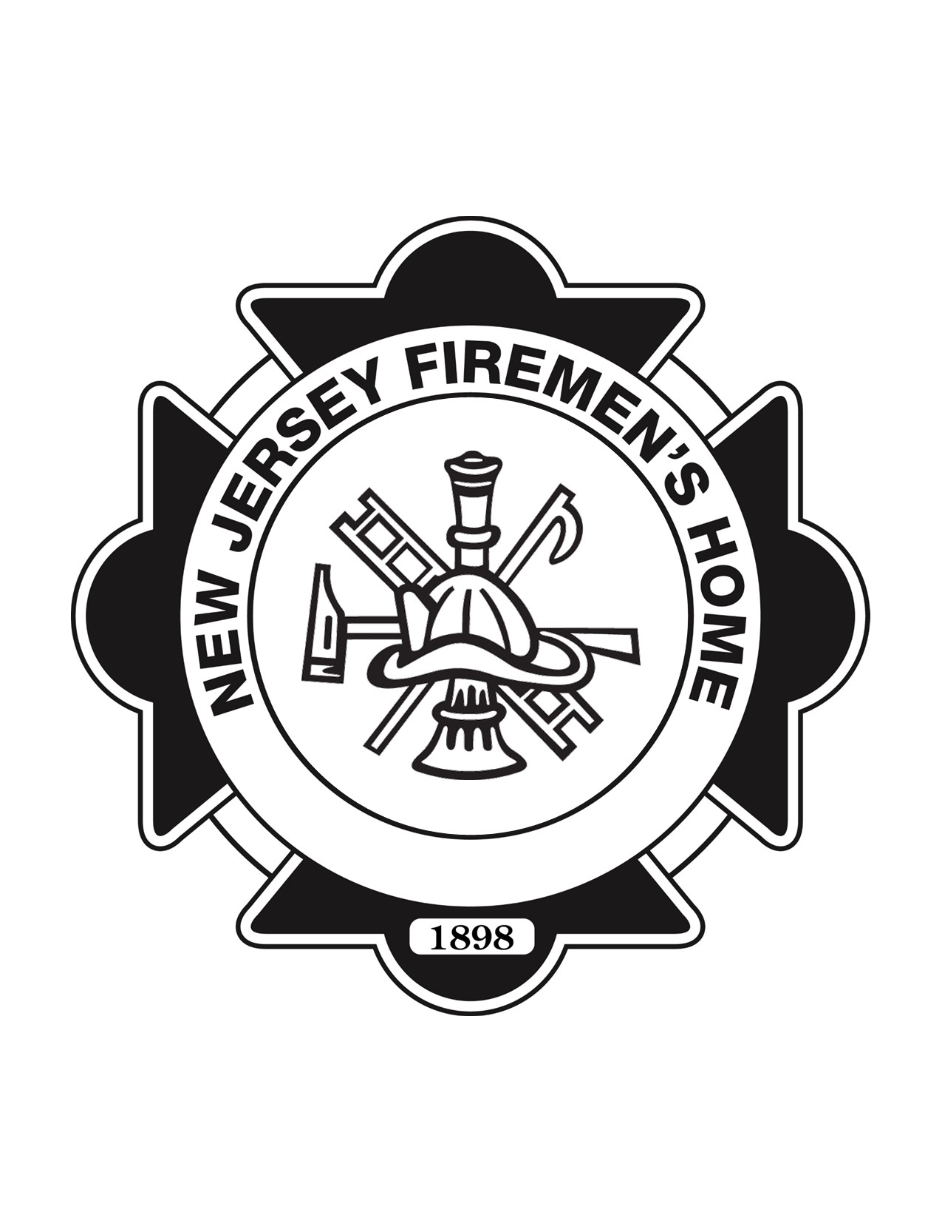

NEW JERSEY FIREMEN'S HOME
Certified Nursing Assistant (CNA) Training Program
Student Application
APPLICANT INFORMATION
Full Name: ________________________________________________
Date of Birth: ________________________________________________
Address: ________________________________________________
City: ________________________________________________
State: ________________________________________________
ZIP Code: ________________________________________________
Phone Number: ________________________________________________
Email Address: ________________________________________________
Preferred Contact Method: ☐ Phone ☐ Email ☐ Text
EMERGENCY CONTACT
Name: ________________________________________________
Relationship: ________________________________________________
Phone: ________________________________________________
Alternate Phone: ________________________________________________
EDUCATION
Highest Level Completed:
☐ High School Diploma ☐ GED ☐ Some College ☐ College Degree ☐ Other __________
School: ________________________________________________
Year Completed: ________________________________________________
EMPLOYMENT INFORMATION
Current Employer: ________________________________________________
Position: ________________________________________________
Employer Phone: ________________________________________________
Currently Employed: ☐ Yes ☐ No
Interested in employment with the New Jersey Firemen's Home after certification? ☐ Yes ☐ No ☐ Maybe
HEALTHCARE EXPERIENCE
Have you previously worked in healthcare? ☐ Yes ☐ No
If yes, describe:
______________________________________________________________
CERTIFICATIONS
☐ CPR ☐ First Aid ☐ Home Health Aide ☐ Medication Aide ☐ EMT ☐ Other __________
Expiration Date(s): ________________________________________________
ELIGIBILITY QUESTIONS
☐ I am legally authorized to work in the United States.
☐ I have sufficient English language proficiency to read, write, speak, and understand English as required to successfully complete the CNA Training Program and provide safe resident care.
If accommodations are needed, please describe:
______________________________________________________________
Can you perform the essential physical duties required of a CNA with or without reasonable accommodation? ☐ Yes ☐ No
Have you ever been convicted of a criminal offense (excluding minor traffic violations)? ☐ Yes ☐ No
If yes, explain:
______________________________________________________________
(A conviction does not automatically disqualify an applicant.)
PROGRAM REQUIREMENTS
☐ Criminal Background Check
☐ Drug Screening
☐ Physical Examination
☐ Immunization Documentation
☐ Tuberculosis Screening
☐ Attendance at all classroom and clinical sessions
Applicant Initials: ________________________________________________
HOW DID YOU HEAR ABOUT OUR PROGRAM?
☐ Friend/Family ☐ Church ☐ Food Pantry ☐ Social Media ☐ Website ☐ Employer ☐ Community Event ☐ Other __________
PERSONAL STATEMENT
Why do you want to become a Certified Nursing Assistant?
______________________________________________________________
______________________________________________________________
ACKNOWLEDGEMENT
I certify that the information provided on this application is true and complete to the best of my knowledge.
Applicant Signature: ________________________________________________
Date: ________________________________________________
OFFICE USE ONLY
Application Received __________
Interview Scheduled ☐ Yes ☐ No
Background Check ☐ Complete ☐ Pending
Drug Screen ☐ Complete ☐ Pending
Accepted ☐ Yes ☐ No ☐ Wait List
Comments:
______________________________________________________________

New Jersey Firemen's Home CNA Training Program
www.njfirecna.com | 973-334-0024 ext. 43

